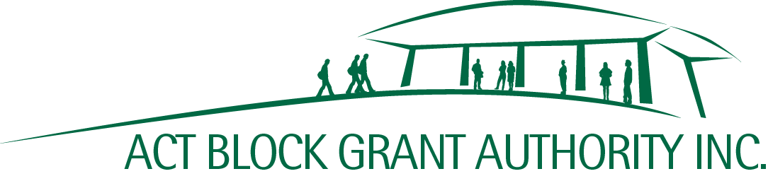
Shop 9, 7 O’Hanlon Place | www.actbga.org.au
Nicholls ACT 2913 | admin@actbga.org.au
ABN: 21 292 628 376 | Phone: (02) 6285 1808

BETTER SCHOOLS FOR OUR KIDS –

NON-GOVERNMENT SCHOOL INFRASTRUCTURE UPGRADES PROGRAM

MILESTONE CLAIM 2 – Commencement of Capital Works

1 | School Name
2 | Project Number
3 | Project Name
4 | Total Grant Approved | (Excl. GST)
5 | Total of Grants Paid to Date | (Excl. GST)
6 | Amount Being Claimed | 20% of Total Grant Approved | (Excl. GST)
7 | Expenditure to Date | Must reconcile with I&E Report and invoices | (Excl. GST)
8 | Approved Due Date of Milestone 3
9 | Estimated Date of Milestone 3  if different to item 8 above
10 | Explanation  if items 8 and 9 above differ
11 | Details of Architect
12 | Details of Builder
13 | Date Contract Signed with Builder

Please ensure the following items are attached:
- Progress Report*
- Copy of Builder’s Insurance
- Copies of Updated Building Plans (if applicable)
- Income and Expenditure Report (must reconcile with item 7 above)
- Copies of invoices (must reconcile with item 7)

Certification

I certify that:
- this claim is correct, and the costs relate only to the above project.
- the Preschool/School is satisfied that the Capital Works are progressing satisfactorily.

Name of Signatory |  | Position of Signatory

Signature |  | Date

* A Progress Report should include an outline of the preschool’s/school’s progress with respect to the Capital Works, along with certification by a competent building industry professional, independent of the builder or project manager that the project is progressing or has been completed in accordance with the Capital Works description in Item 2 Schedule 2 of the Deed of Grant.

