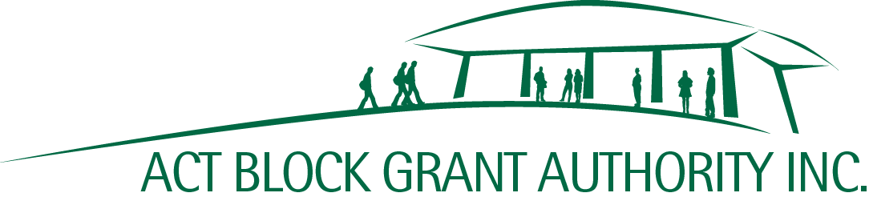
Shop 9, 7 O’Hanlon Place | www.actbga.org.au
Nicholls ACT 2913 | admin@actbga.org.au
ABN: 21 292 628 376 | Phone: (02) 6285 1808

BETTER SCHOOLS FOR OUR KIDS –

NON-GOVERNMENT SCHOOL INFRASTRUCTURE UPGRADES PROGRAM

MILESTONE CLAIM 5 – Final Acquittal

1 | School Name
2 | Project Number
3 | Project Name
4 | Total Grant Approved | (Excl. GST)
5 | Total of Grants Paid to Date | (Excl. GST)
6 | Amount Being Claimed | (15% of Total Grant Approved) | (Excl. GST)
7 | Expenditure Since Milestone 4 Claim | (must reconcile with total cost of attached invoices) | (Excl. GST)
8 | Total Project Expenditure | (must reconcile with I&E Report and total cost of all invoices) | (Excl. GST)

Please ensure the following items are attached:

- Accountant's Certificate*
- Income and Expenditure Report (must reconcile with Accountant’s Certificate and item 8 above)
- Copies of Remaining Invoices (must reconcile to item 7 above)

*The Accountant’s Certificate is available for download at https://actbga.org.au.

Certification

I certify that:
- this claim is correct, and the costs relate only to the above project.
- All project invoices have been accounted for and the Preschool/School does not anticipate any further expenditure in relation to this project.

Name of Signatory |  | Position of Signatory

Signature |  | Date

