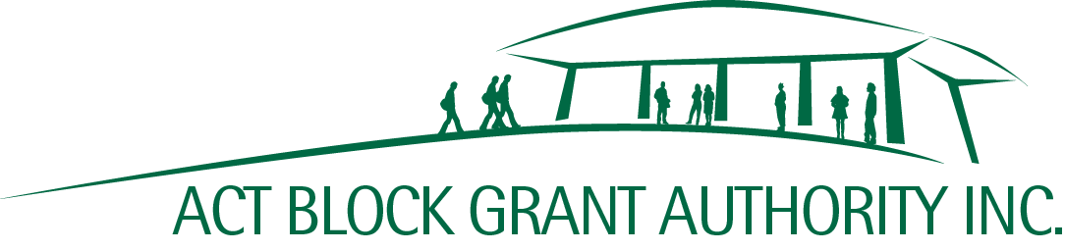
Shop 9, 7 O’Hanlon Place | Email | admin@actbga.org.au
Nicholls ACT 2913 | Phone | (02) 6285 1808
ABN | 21 292 628 376

NON-GOVERNMENT SCHOOL
PARENT ENGAGEMENT GRANTS PROGRAM

Final Acquittal

1 | Parent Association or School Name
2 | Project Number
3 | Project Title
4 | Total Grant Approved | (Excl. GST)
5 | Total Grant Expenditure* | (Excl. GST)
6 | Total Project Expenditure | (must reconcile with I&E Report and total cost of all invoices) | (Excl. GST)

*If the Total Grant Expenditure (5) is less than the approved amount, the ACTBGA will contact the grant recipient to arrange for the remaining funds to be returned, as per the signed Deed of Grant.

Please ensure the following items are attached:

☐ Certification of Project Completion
☐ Income and Expenditure Report (must reconcile with item 6 above)
☐ Copies of Project Invoices (must reconcile with item 6 above)

Certification

I certify that:
- This acquittal information is correct, and the costs relate only to the above project.
- All project invoices have been accounted for and the grant recipient does not anticipate any further expenditure in relation to this project.

Name of Signatory |  | Position of Signatory

Signature |  | Date

